#The first thing we want to do is add the deployed machine’s IP and host name to /etc/hosts:

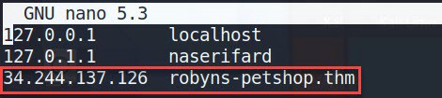
Let’s do a port scan:

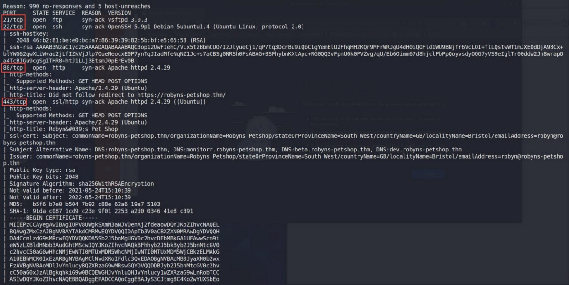
There is a few ports opened.
Let’s start with what looks to be a website on port 443. Going to the website we’re first presented with a warning. We can see there is a self signed certificate in use for this site. Click View Certificate to have a look:

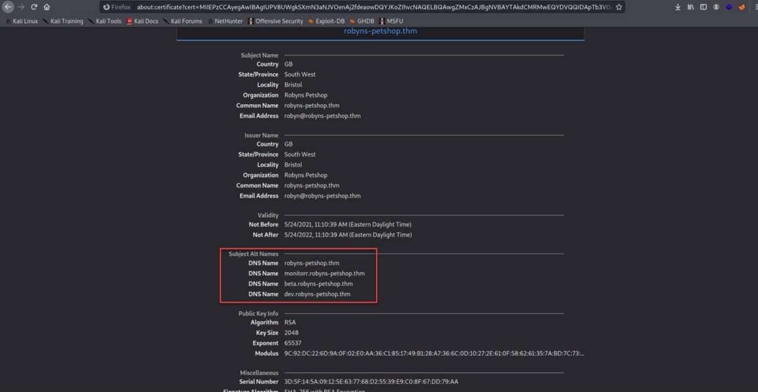
This reveals the certificate has three additional Subject Alternate Names.
Let’s add them to our hosts file:

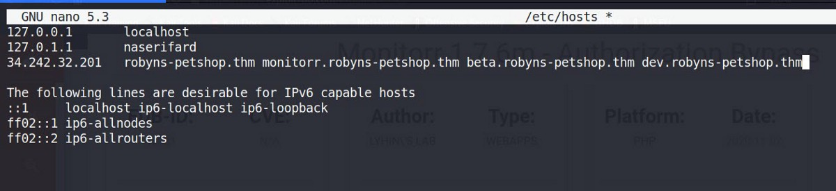
Continuing on to the site we see a single static page:

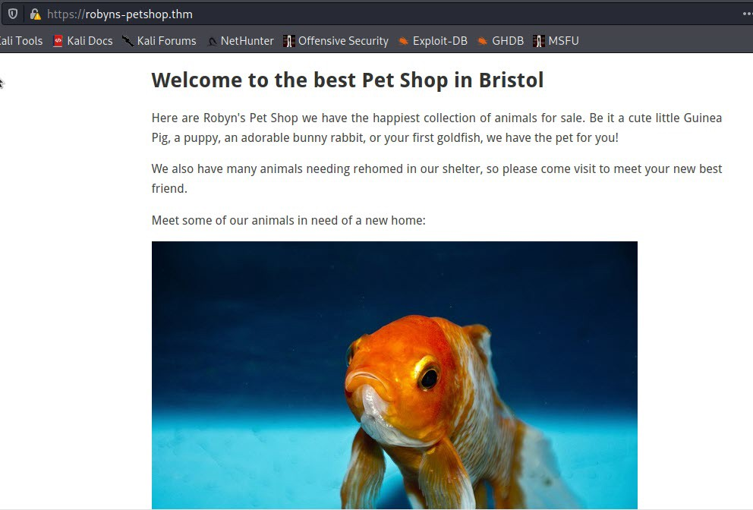
Looking at dev.robyns-petshop.thm and beta.robyns-petshop.thm. there is Nothing noteworthy. Now let’s look at the monitorr.robyns-petshop.thm subdomain:

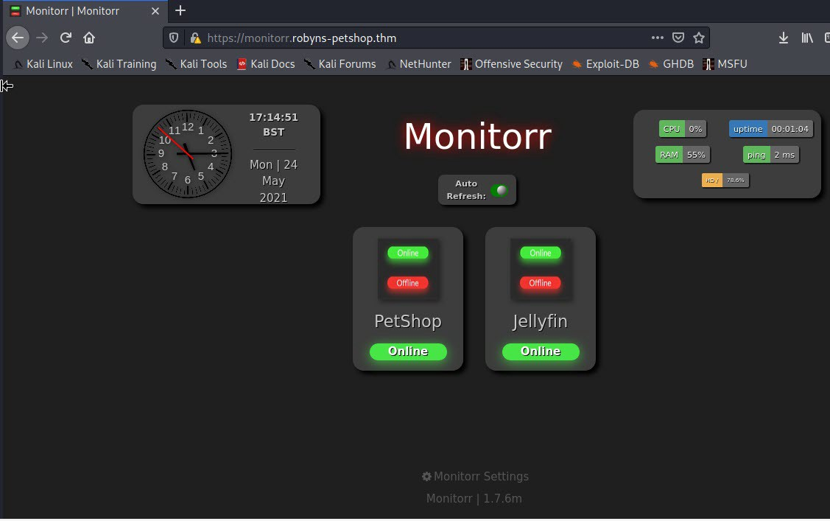
according to GitHub link: Monitorr is a web-front to live display the status of any web-app or service.
I notice a version number at the bottom of the page: 1.7.6m
let’s check searchsploit:

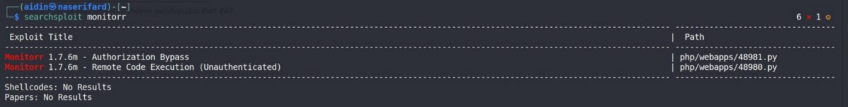
let’s use this exploits. The first one is Authorization bypass. Let’s have a look at it:

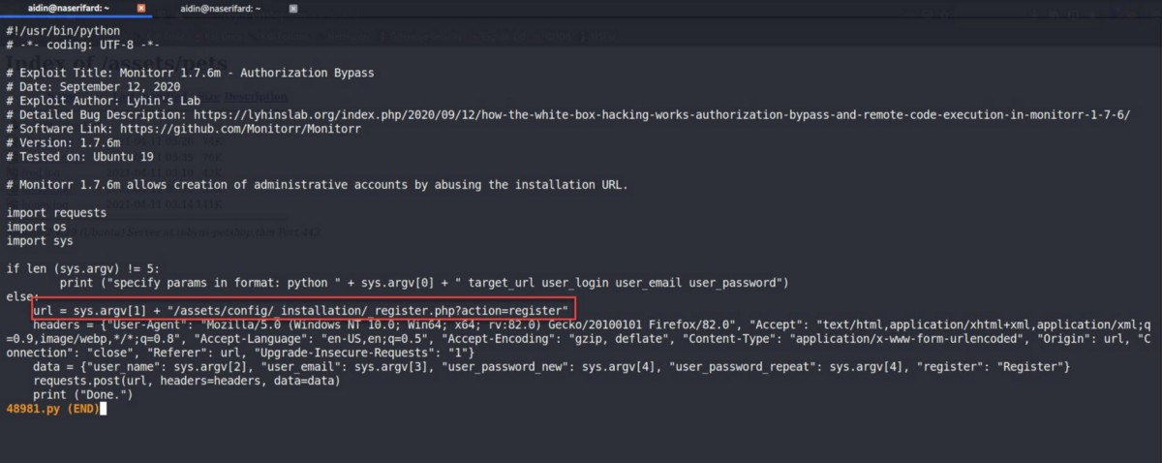
Unfortunately, if we browse “/assets/config/_installation/_register.php” we see is isn’t accessible:

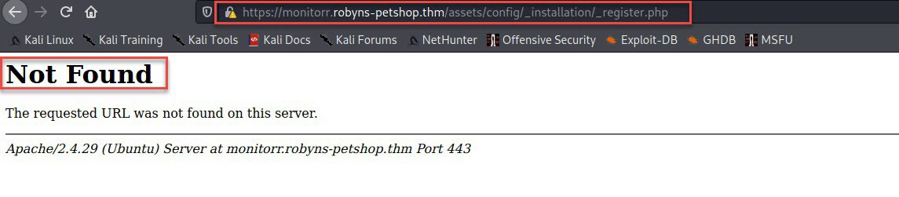
Let’s have a look at the other exploit:

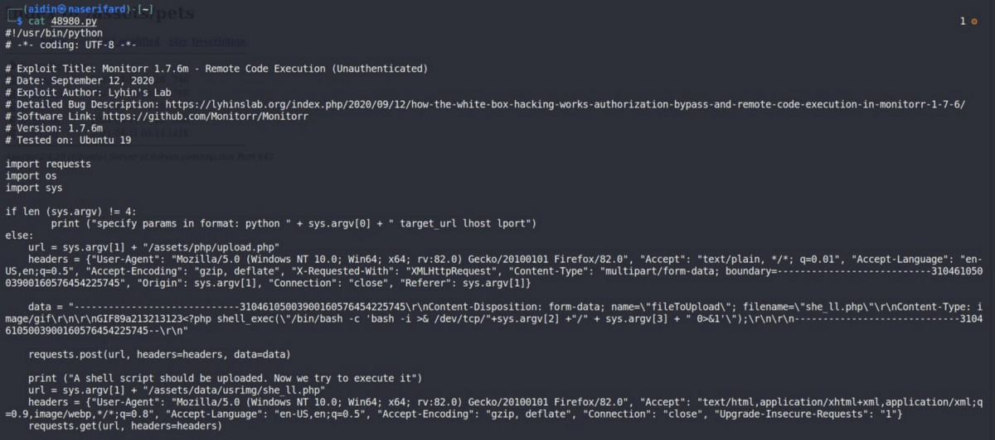
Browsing to “/assets/php/upload.php”:

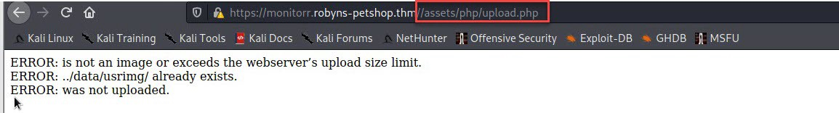
OMG! Let’s try the exploit:

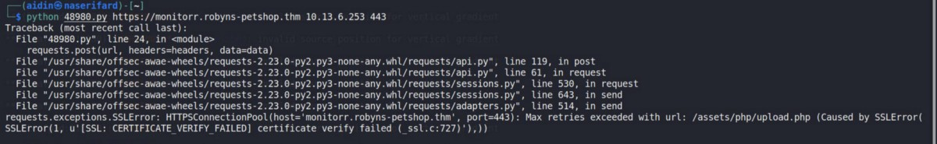
This python script doesn’t handle SSL connections. We can add verify=False to the post and get requests to ignore certificate checks:

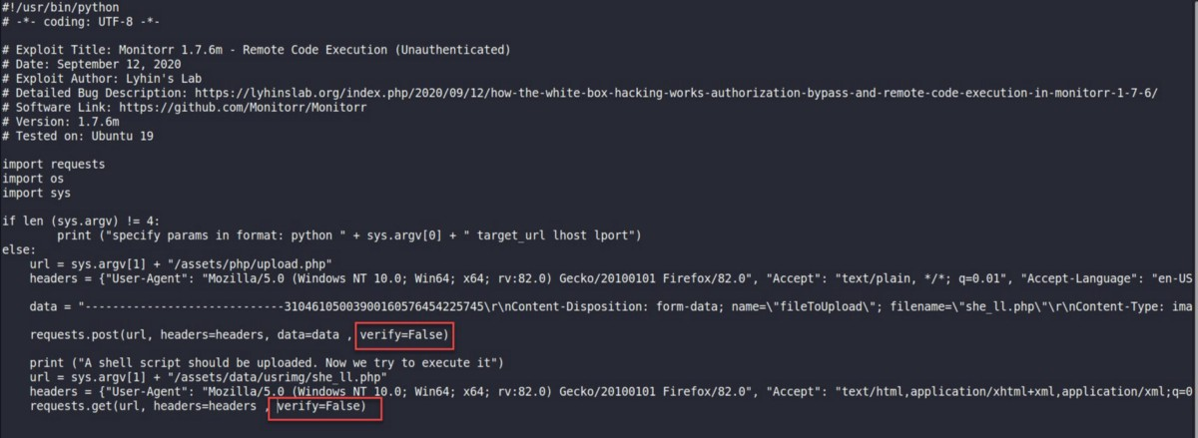
now, exploit again:

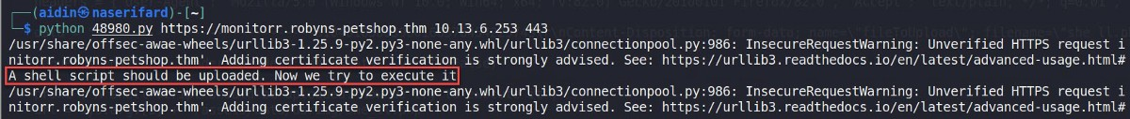
It says “A shell script should be uploaded.” according the exploit code, the file should have been uploaded in this path: “/assets/data/usrimg”. oh, nothing uploaded:

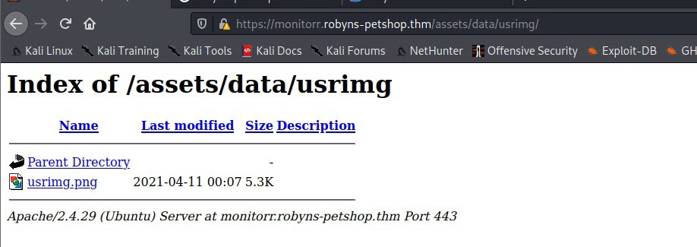
Let’s print the response code to see what happened:

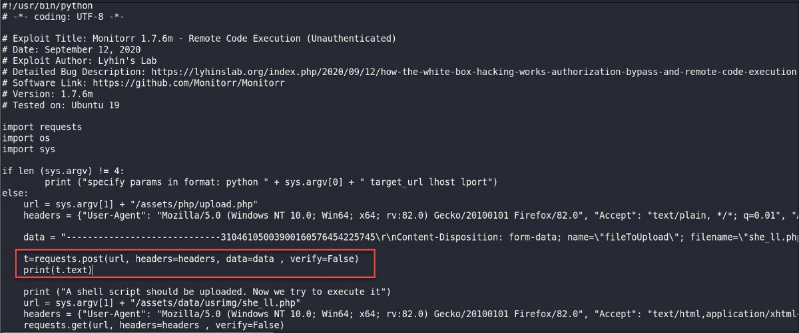
Something track us and prevents this exploit from running:

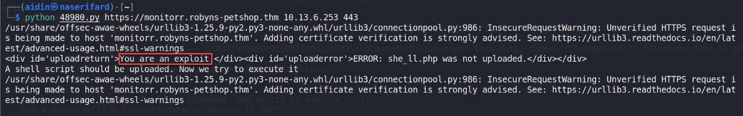
check the browser for for cookies. there is a cookie called “isHuman”: “1”.

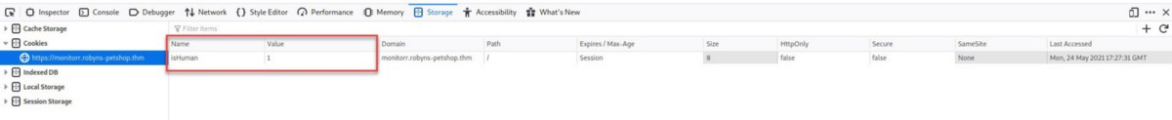
Add this cookie to post and get requests:

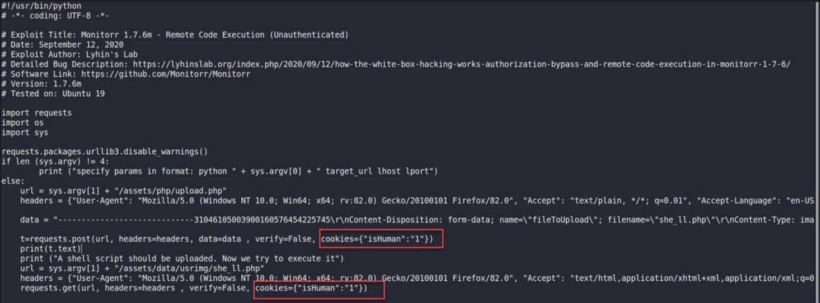
and exploit again:

We can see an error: “she_ll.php is not an image”!
let’s debug the exploit code and use bypass file upload methods (double extension):

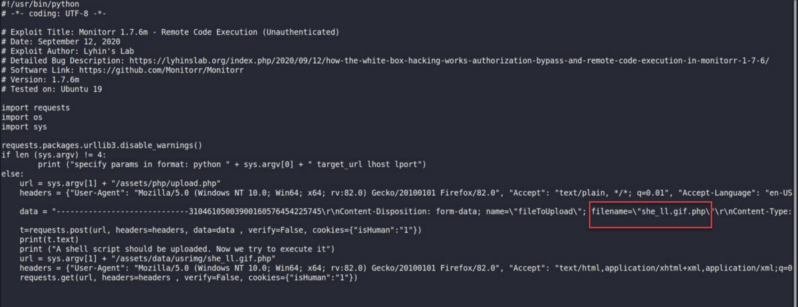
It still did not work:

let’s see if the security check is case sensitive:

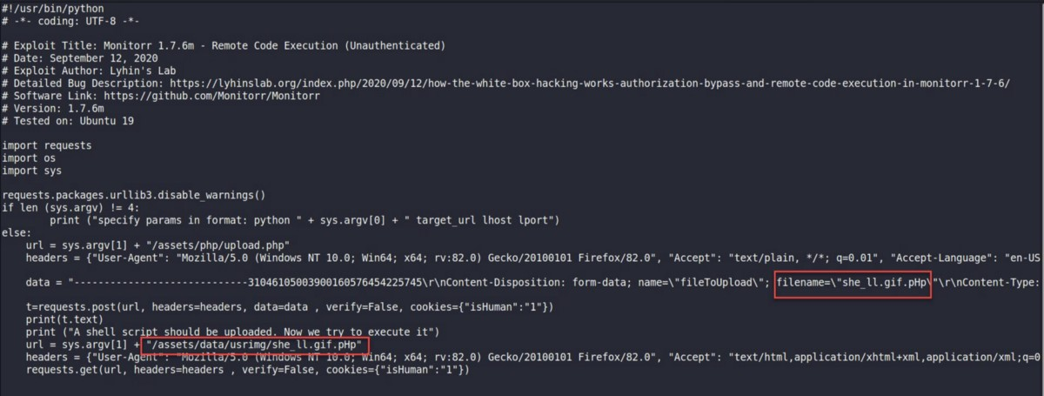
That worked. it was just looking for lower case php, not uppercase!

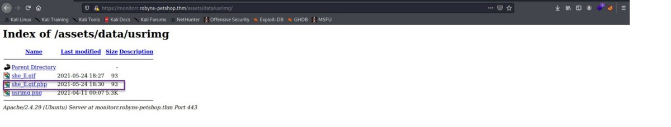
switching to my listener, and at last we have a shell connected:

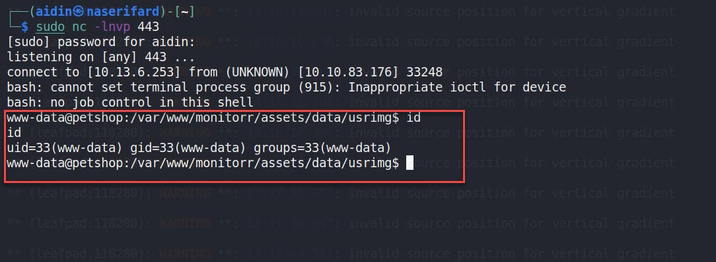
Let’s upgrade to a better fully interactive shell

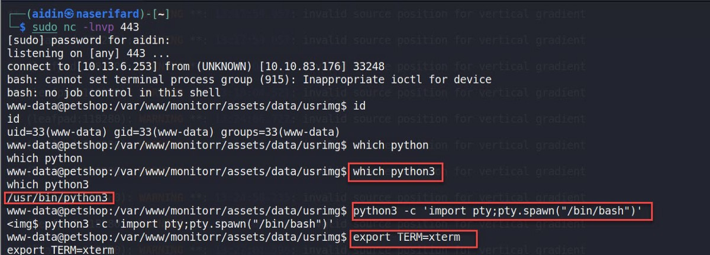
Let’s find the first flag:

Privilege Escalation
I used linpeas to enumerating. after a while, in SGID section, I found a custom SUID file snap because all the items were green except this one.

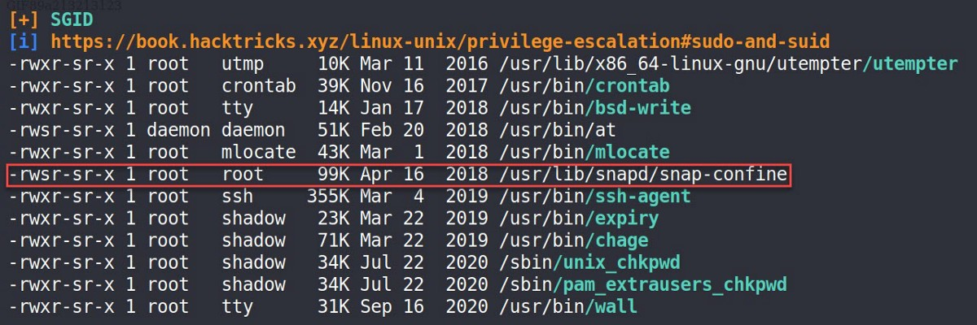
check the version installed on the machine:

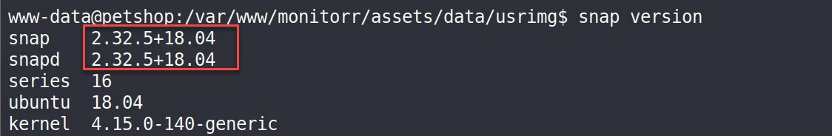
let’s check searchsploit for snapd available exploits:

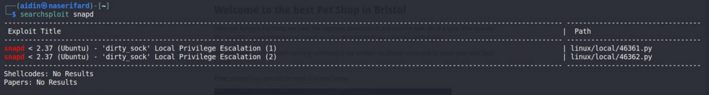
Let’s try both exploits by downloading and executing direct from GitHub with wget. The second exploit worked.

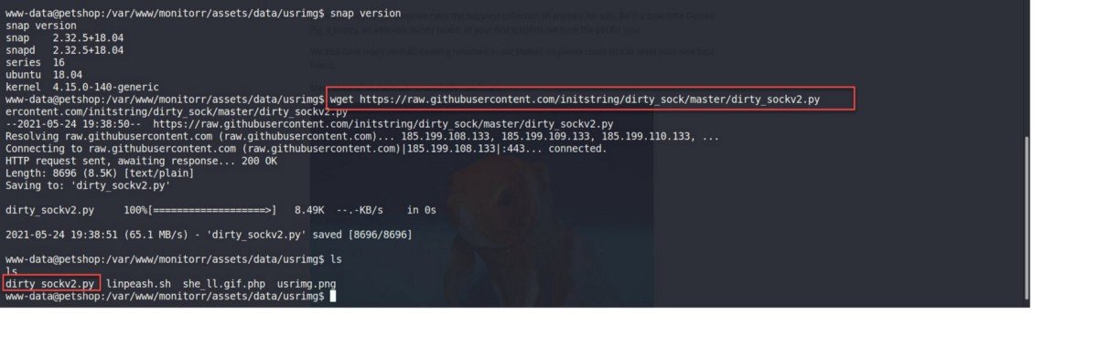
We are root now and we can getting root flag from /root/root.txt.

